## Git Repository Report

Using a git repository for collaboration contains several steps and has a different approach.

1. Initializing git repository

Step 1: create a remote repository on github or git lab.

Step 2:create a project on a local device.

Step 3: initialise project folder as git folder by using ‘git init’ command

Step 4: make initial commit by using following command:

* Git add -A
* Git commit -m “<message>”

Step 5: connect local project folder to remote git repository by following command:

* Git add remote <remote name> <git url>

Eg: git add remote origin <https://github.com/junaidkv/sample.git>

Step 6: make new branches if needed

* Git checkout -b <branch name>

Eg: git checkout -b development/ui

Step 7: push committed changes to remote repository

* Git push -u -f <remote name> <branch name>

Eg: git push -u -f origin development/ui

After step 7 the contents in local project repository will be uploaded to remote repository

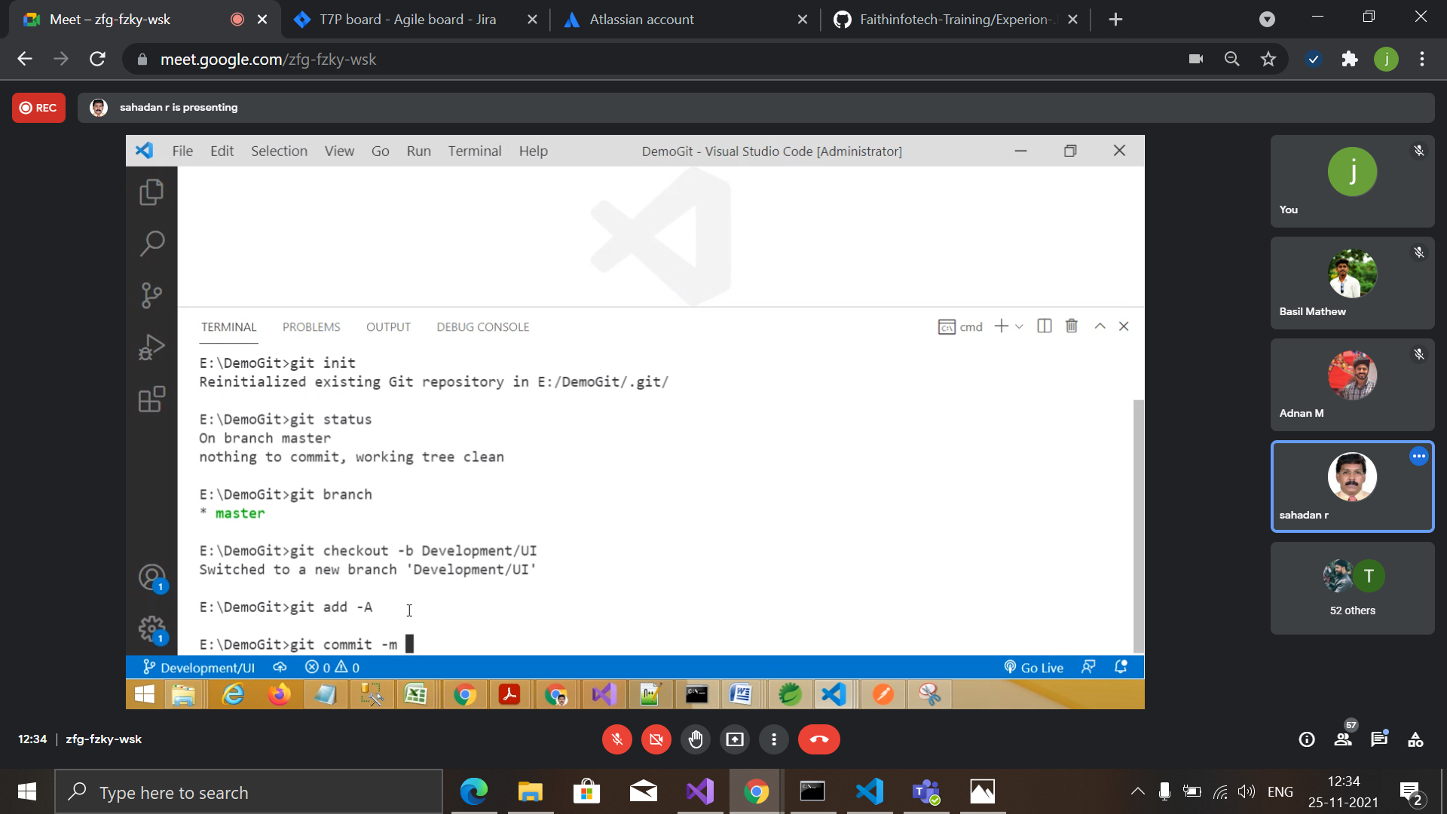

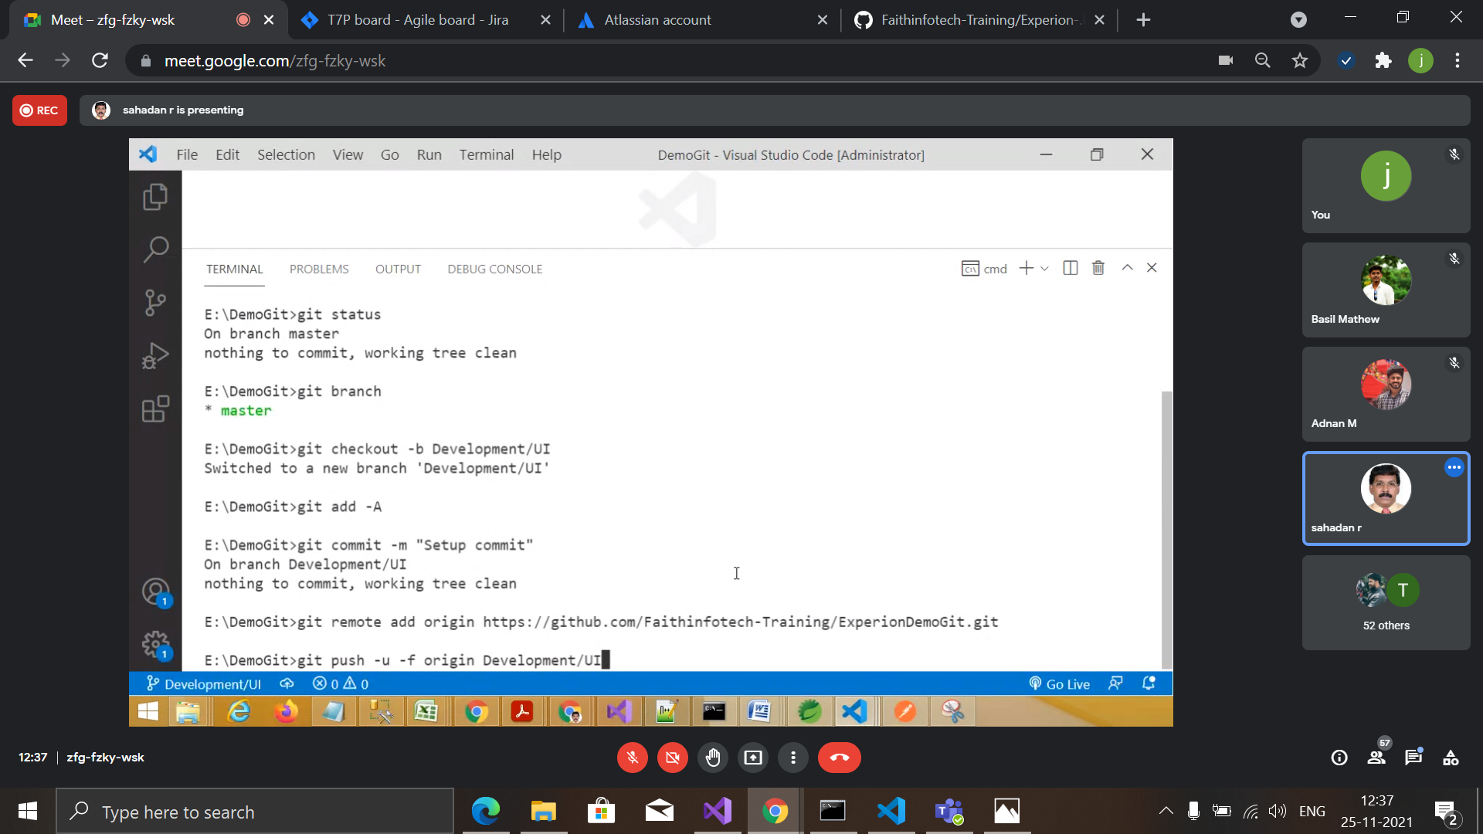

1. Clone and using existing git repository

Step1 : use following command to clone existing remote git repository and use it in local system.

* Git clone <url> - -branch <branch>

Eg: git clone <https://github.com/junaidkv/sample.git> - - branch development/ui

Step 2: after making any changes and want to upload it to a remote repository use the following commands.

* Git add <file name>

or

git add -A

* Git commit -m “<message>”
* Git push <remote name> <branch>

Eg: git push origin development/ui

1. After initialising and cloning procedure every time when a user wants to upload their changes they have to take a pull from a remote repository.

* Git checkout <branch>

Eg:git checkout development/ui

* Git pull

Note: Sometimes git pull will result conflicts in the file so we have to check where the conflict is occurring and resolve the conflict git gui system enable 3 option for resolving the conflict that are

* Accept incoming
* Accept local
* Accept both

We have to choose this options accordingly and after all the conflict are resolved,

Make the changes as staged and commit the changes.

* Git add -A
* Git commit -m ”<message>”